Title of the article should be written in compact, clear, and informative sentence, preferably not more than 20 words (16pt)
Widodo¹, Muhammad Jafar Luthfi² (10.5 pt)
¹Biology Education Department, ²Biology Department, Faculty of Science and Technology, UIN Sunan Kalijaga,
Jl. Marsda Adisucipto No 1 Yogyakarta 55281, Indonesia. Tel. +62-274-540971, Fax. +62-274-519739. ¹Email: wwidodo@ychoo.com (Center, 8.5 pt)
Abstract. A concise abstract is required (± 300 words). The abstract should be informative and state briefly the aim of the research, the principal results and major conclusions. An abstract is often presented separately from the article, thus it must be able to stand alone (completely self-explanatory). References should not be cited, but if essential, then cite the author(s) and year(s). Abbreviations should be avoided, but if essential, they must be defined at their first mention. (9 pt)
Keywords: Keywords is about five words, covering scientific and local name (if any), research theme, and special methods which used; and sorted from A to Z. (9 pt)
Abbreviations (if any): All important abbreviations must be defined at their first mention there. Ensure consistency of abbreviations throughout the article.
Running title: a short title with five words

INTRODUCTION (10.5 pt)
Introduction is about 400-600 words, covering the aims of the research and provide an adequate background, avoiding a detailed literature survey or a summary of the results. Indicate the aims of research in the last paragraph. (10.5 pt)
Manuscript of original research should be written in no more than 8,000 words (including tables and picture), or proportional with articles in this publication number. Review articles will be accommodated, while, short communication should be written in about 2,000 words, except for pre-study.
Manuscript is typed on white paper of A4 (210x297 mm²) size, in a single column single space, 10.5-point Times New Roman font, with margin text from the top is 2 cm, from the bottom is 2 cm, left and bottom are 1.7 cm. Smaller lettering size can be applied in presenting table and figure (8 pt). Word processing program or additional software can be used, however, it must be PC compatible and Microsoft Word based (.doc or .docx). Scientific names of species (incl. subspecies, variety, etc.) should be written in italic, except for italic sentence. Scientific name (genera, species, author), and cultivar or strain should be mentioned completely for the first time mentioning it in the body text, especially for taxonomic manuscripts. Name of genera can be shortened after first mentioning, except generating confusion. Name of the author can be eliminated after first mentioning. For example, Rhizopus oryzae L. UICC 524, hereinafter can be written as R. oryzae UICC 524. Using trivial name should be avoided, otherwise generating confusion. Biochemical and chemical nomenclature should follow the order of the IUPAC - IUB. For DNA sequence, it is better used Courier New font. Symbols of standard chemical and abbreviation of chemistry name can be applied for common and clear used, for example, completely written butilic hydroxytoluene (BHT) to be BHT hereinafter. Metric measurement use IS denomination, usage other system should follow the value of equivalent with the denomination of IS first mentioning. Abbreviations set of, like g, mg, mL, etc. do not follow by dot. Minus index (m⁻², L⁻¹, h⁻¹) suggested to be used, except in things like “per-plant” or “per-plot”. Equation of mathematics does not always can be written down in one column with text, in that case can be written separately. Number one to ten are expressed with words, except if it relates to measurement, while values above them written in number, except in early sentence. The fraction should be expressed in decimal. In the text, it should be used “%” rather than “percent”. Avoid expressing ideas with complicated sentence and verbiage, and used efficient and effective sentence.
Citation in manuscript is written in “name and year” system; and is arranged from oldest to newest and from A to Z. In citing an article written by two authors, both of them should be mentioned, however, for three and more authors, only the last (family) name of the first author is mentioned, followed by et al. (not italic), for example: Saharjo and Nurhayati (2006) or (Boonkerd 2003a, b, c; Sugiyarto 2004; El-Bana and Nijs 2005; Balagadde et al. 2008; Webb et al. 2008). Extent citation as shown with word “cit” should be avoided. Reference to unpublished data and personal communication should not appear in the list but should be cited in the text only (e.g., Rifai MA 2007, pers. com. (personal communication); Setyawan AD 2007, unpublished data). A total of 80% of the references should be from scientific journals published in the last five years, except for taxonomic studies. Names of journals should be abbreviated according to the ISSN List of Title Word Abbreviations (www.issn.org/2-22661-LTWA-online.php).
MATERIALs AND METHODS (10.5 pt)
Study area (10.5 pt)
Materials and Methods should emphasize on the procedures and data analysis. For field study, it is better if study site is included (Figure 1).

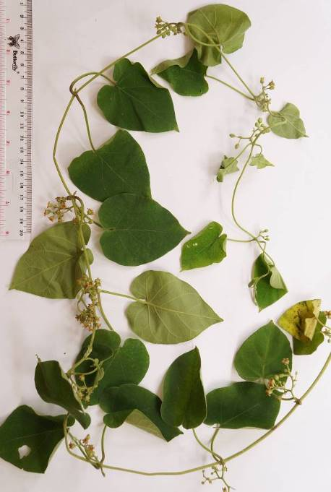

Figure 1. Marsdenia tenacissima found by author on Gunung Ijo Flowering twigs. ( Figure, 8 pt)
Procedures
Sub-procedures-1 (replace with your sub-sub-title of procedures)
Xxxxxx.
Sub-procedures-2
Xxxxxx.
Data analysis
Xxxxxx.
RESULTS AND DISCUSSION
Results and Discussion should be written as a series of connecting sentences, however, for manuscript with long discussion should be divided into subtitles. Results should be clear and concise.
Result-1 (replace with your sub-sub-title of result)
Figures and tables of maximum of three pages should be clearly presented. Number tables consecutively in accordance with their appearance in the text. Title of a picture is written down below the picture, while title of a table is written above the table. Colored figures can only be accepted if the information in the manuscript can lose without those images; chart is preferred to use black and white images. Author could consign any picture or photo for the front cover, although it does not print in the manuscript. All images property of others should be mentioned source. There is no appendix, all data or data analysis are incorporated into Results and Discussions. For broad data, it can be displayed on the website as a supplement (Figure 2; Table 1).
Result-2
Xxxxxxxxx (Table 2).
Xxxxxxxxx (Figure 3).

Table 1. Description of Backer & Bakhuizen (1965) on Marsdenia crocea. (8 pt)

Plants parts | Description
Flower, Pollinia | Fre part of corona-scales narrowly ovate, obtuse, reaching to about half the height of the stigma; back of connate part ridge shaped, opened towards the base; translators several times shortter than pollinia; panicles broadly pyramidal, c. 5 cm long; pedicels 5-7 mm; calyx c. 3 mm; segments ovate-elliptic, obtuse; corolla c. 6 mm, yellowish white, outside more densely hairy in the upper half than the lower; tube on the side with basal tufts on long hairs, c. 3,5 mm long; segments glabrous inside, with a thickened rim at the base (in the throat), c. 2,5 mm long; gynostegium subequalling the corolla-tube; stigma broadly conical, obtuse.
Leaves | Leaves cordate, shortly acuminate, thinly grey-pubescent above, more densely so above, palmatinerved, with distint lateral nerves, finely reticulate-veined, 5-10 cm by c. 6 cm; petiole c. 3 cm.
Information | Very long ago collected in East Java
Note: Xxxxxx
Discussion
Thorough discussion represents the causal effect mainly explains for why and how the results of the research were taken place, and do not only re-express the mentioned results in the form of sentences, not repeat them. Concluding sentence should be given at the end of the discussion.
ACKNOWLEDGeMENTS
Acknowledgments are expressed in a brief; all sources of institutional, private and corporate financial support for the work must be fully acknowledged, and any potential conflicts of interest are noted.
REFERENCES
Journal:
Saharjo BH, Nurhayati AD. 2006. Domination and composition structure change at hemic peat natural regeneration following burning; a case study in Pelalawan, Riau Province. Biodiversitas 7: 154-158.
Book:
Rai MK, Carpinella C. 2006. Naturally Occurring Bioactive Compounds. Elsevier, Amsterdam.
Chapter in book:
Webb CO, Cannon CH, Davies SJ. 2008. Ecological organization, biogeography, and the phylogenetic structure of rainforest tree communities. In: Carson W, Schnitzer S (eds) Tropical Forest Community Ecology. Wiley-Blackwell, New York.
Abstract:
Assaeed AM. 2007. Seed production and dispersal of Rhazya stricta. 50th annual symposium of the International Association for Vegetation Science, Swansea, UK, 23-27 July 2007.
Proceeding:
Alikodra HS. 2000. Biodiversity for development of local autonomous government. In: Setyawan AD, Sutarno (eds) Toward Mount Lawu National Park; Proceeding of National Seminary and Workshop on Biodiversity Conservation to Protect and Save Germplasm in Java Island. Sebelas Maret University, Surakarta, 17-20 July 2000. [Indonesian]
Thesis, Dissertation:
Sugiyarto. 2004. Soil Macro-invertebrates Diversity and Inter-Cropping Plants Productivity in Agroforestry System based on Sengon. [Dissertation]. Brawijaya University, Malang. [Indonesian]
Information from internet:
Balagadde FK, Song H, Ozaki J, Collins CH, Barnet M, Arnold FH, Quake SR, You L. 2008. A synthetic Escherichia coli predator-prey ecosystem. Mol Syst Biol 4: 187. www.molecularsystemsbiology.com

